Ideation Phase

Define the Problem Statements

Date | 1 November 2025
Team ID | NM2025TMID09066
Project Name | Streamlining Ticket Assignment for Efficient  Support Operations
Maximum Marks | 2 Marks

Customer Problem Statement Template:
At ABC Corporation, customers frequently experience delays in issue resolution after submitting support tickets. They often face frustration due to tickets being assigned to the wrong teams, leading to longer wait times and repeated follow-ups. Customers expect quick, accurate, and transparent support that resolves their problems efficiently. However, the current manual routing process lacks consistency and speed, resulting in dissatisfaction and reduced trust in the support system.
Customers need a streamlined, automated ticket assignment experience that ensures their issues are directed to the right experts without unnecessary delays. By implementing an automated ticket routing system in ServiceNow, ABC Corporation can create a smoother, faster, and more reliable support experience that aligns with customer expectations and builds long-term satisfaction.

Section | Details
I am | A customer of ABC Corporation who relies on prompt and accurate technical support for resolving issues related to platform access, user accounts, and certifications.
I'm trying to | Get my technical issues resolved quickly by the correct support team without unnecessary delays or repeated ticket transfers.
But | My tickets are often assigned to the wrong teams, causing long waiting times, multiple follow-ups, and delayed problem resolution.
Because | The current ticket assignment process is manual, lacks automation, and depends on human decision-making, leading to inefficiencies and misrouting.
Which makes me feel | Frustrated, undervalued, and dissatisfied as I spend too much time waiting for help and lose confidence in the company’s support system.

Example:
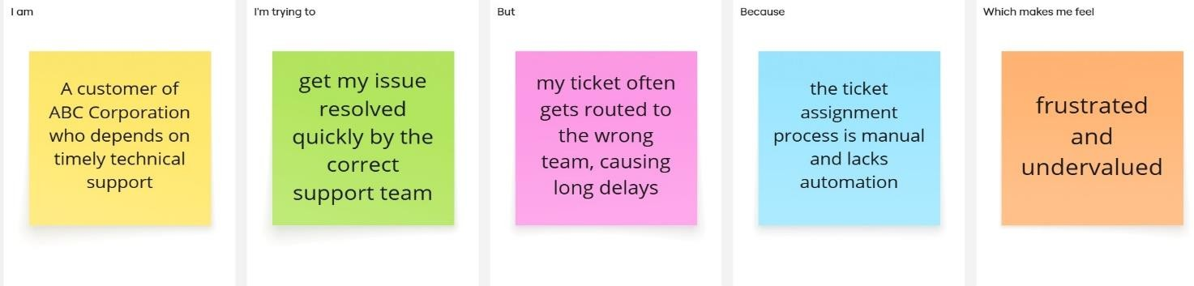

Problem  Statement (PS) | I am  (Customer) | I’m trying to | But | Because | Which makes me feel
PS-1 | A Support Agent | Resolve customer tickets quickly and efficiently | Tickets are often routed to the  wrong team | The ticket assignment process is manual and  lacks automation | Overwhelmed and delayed in responding to customers
PS-2 | A Customer | Get my issue resolved by the right team without delay | My ticket keeps getting transferre d between departme  nts | There is no automated system to categorize and assign tickets correctly | Frustrated and undervalued

Problem Statement PS 1:
As a support agent, I’m trying to resolve customer tickets efficiently, but the current manual routing process often sends tickets to the wrong team.Because of this, I spend extra time redirecting tickets or waiting for reassignment, which slows down response times and increases workload. This makes me feel overwhelmed and ineffective, as I’m unable to focus on solving actual customer issues. An automated system that intelligently assigns tickets to the right team would reduce confusion and help streamline the workflow.

Problem Statement PS 2:
As a customer, I want my issues to reach the correct support team quickly so they can be resolved without unnecessary delays. But currently, my tickets are often misrouted or take too long to be addressed. Because the system lacks automated ticket classification and routing, I end up waiting longer for resolutions. This makes me feel frustrated and undervalued, as it appears my concerns are not being prioritized. Implementing an automated ticket routing process in ServiceNow would ensure faster, more accurate support responses and a better customer experience.

